**SWEN6837 - Software Engineering Capstone Project**

Professor: Dr. Findler

[findler@uhcl.edu](mailto:findler@uhcl.edu)

Done & Reviewed By:

Chandra Mouli Basava

Anusha Samudrala

Tejaswi Yallualla

Siva Kiran Reddy Telluri

Kavya Kiran Kammaripalle

Aditya Thummala

Nikhil Mayukuntla

Hilary Mokolo

Vrunda Rana

Sameer Walunj

Manish Toutireddy

**Purpose:**

AR flood simulator purpose is to stream the affected flood areas using hollow lens and can predict the potential flood zone areas using map box. It also provides awareness among the people about the impact and level of flooding at specific areas.

**Scope:**

AR flood simulator helps to gain a sense of risk within environment. It helps to provide proper locations for well planning of the city construction. By using historical data, we can provide safety measures in advance.

**Brainstorming:**

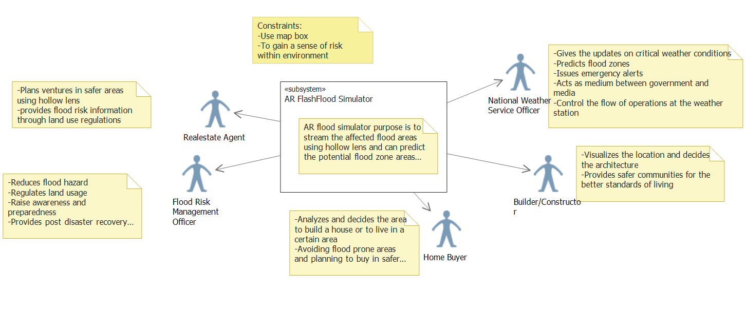

**Use Cases:**

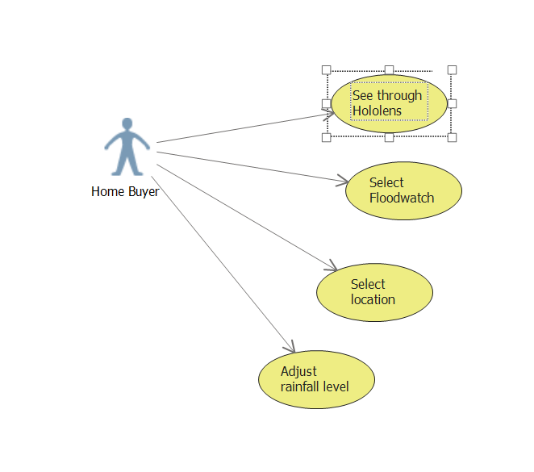

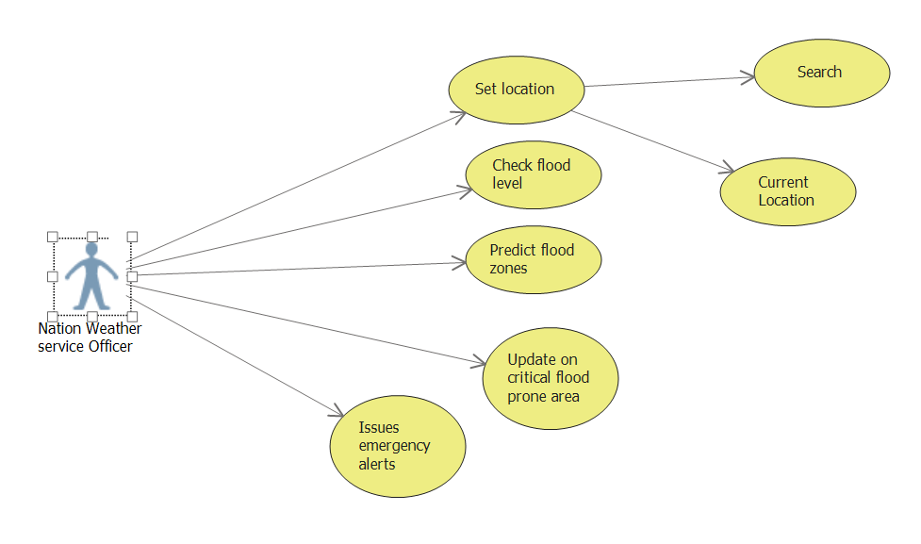

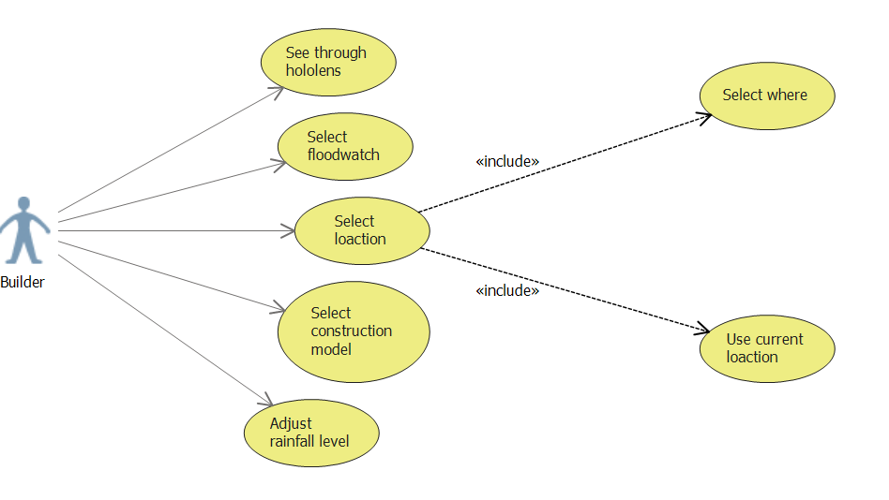

**Architecture:**

